|  |
| --- |
|  |

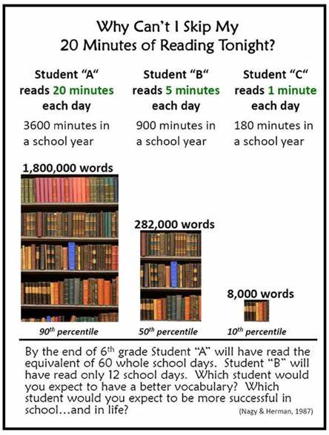

|  |
| --- |
| ***“Good readers are made on the lap of a parent”*** |

|  |
| --- |
|  |

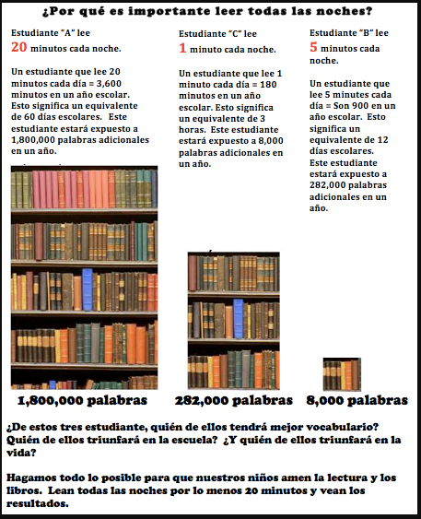

**“Los buenos lectores se hacen en el regazo de un padre”.**